SNES Gamepad Adapter for Commodore PET Rev.1
Module Description

Introduction
The SNES Gamepad Adapter for PET works with the respective games found on Bo Zimmerman’s website zimmers.net and PETSCII robots by the 8bit guy.
The source of information about the hardware requirements is the file snes_adapter.zip from zimmers.net. A further source was https://wiki.superfamicom.org/schematics-ports-and-pinouts#. The zimmers.net file contains references to texelex.com and Steve Lewis plus source code in C and BASIC for polling the gamepad.
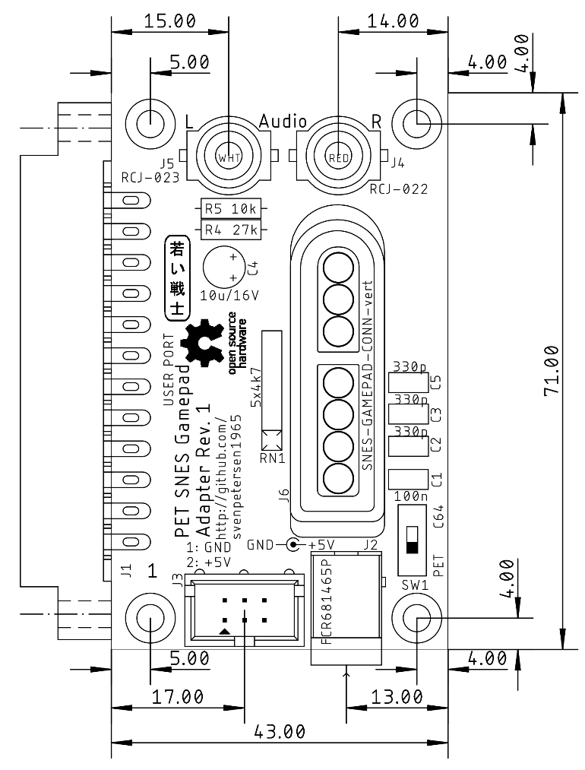
Figure 1: PET SNES Gamepad Adapter Rev. 0 (Dimensions)
Since the PET User Port does not provide +5V supply voltage, there is a 6 was box pin header form connecting a cassette port dongle (where +5V can be tapped for the Gamepad. This is the recommended solution. Further, there is a 5.5mm/2.1mm barrel connector for a +5V external PSU. For the C64, the switch SW1 can be set to “C64” to use the +5V from the C64 User Port.
WARNING: Never connect to board to a PET with SW1 in the C64 position, since this might cause damage to the PET.
The CB2 audio is tapped from the user port and connected to two RCA jacks via a voltage divider and a capacitor for connecting external PC speakers.
The adapter works with PETSCII Robots for the C64, as well. Since the 5V of the C64 are not connected (that would be the TVVIDEO pin of the user port), either a Cassette Port Dongle or an external Power Supply is required.
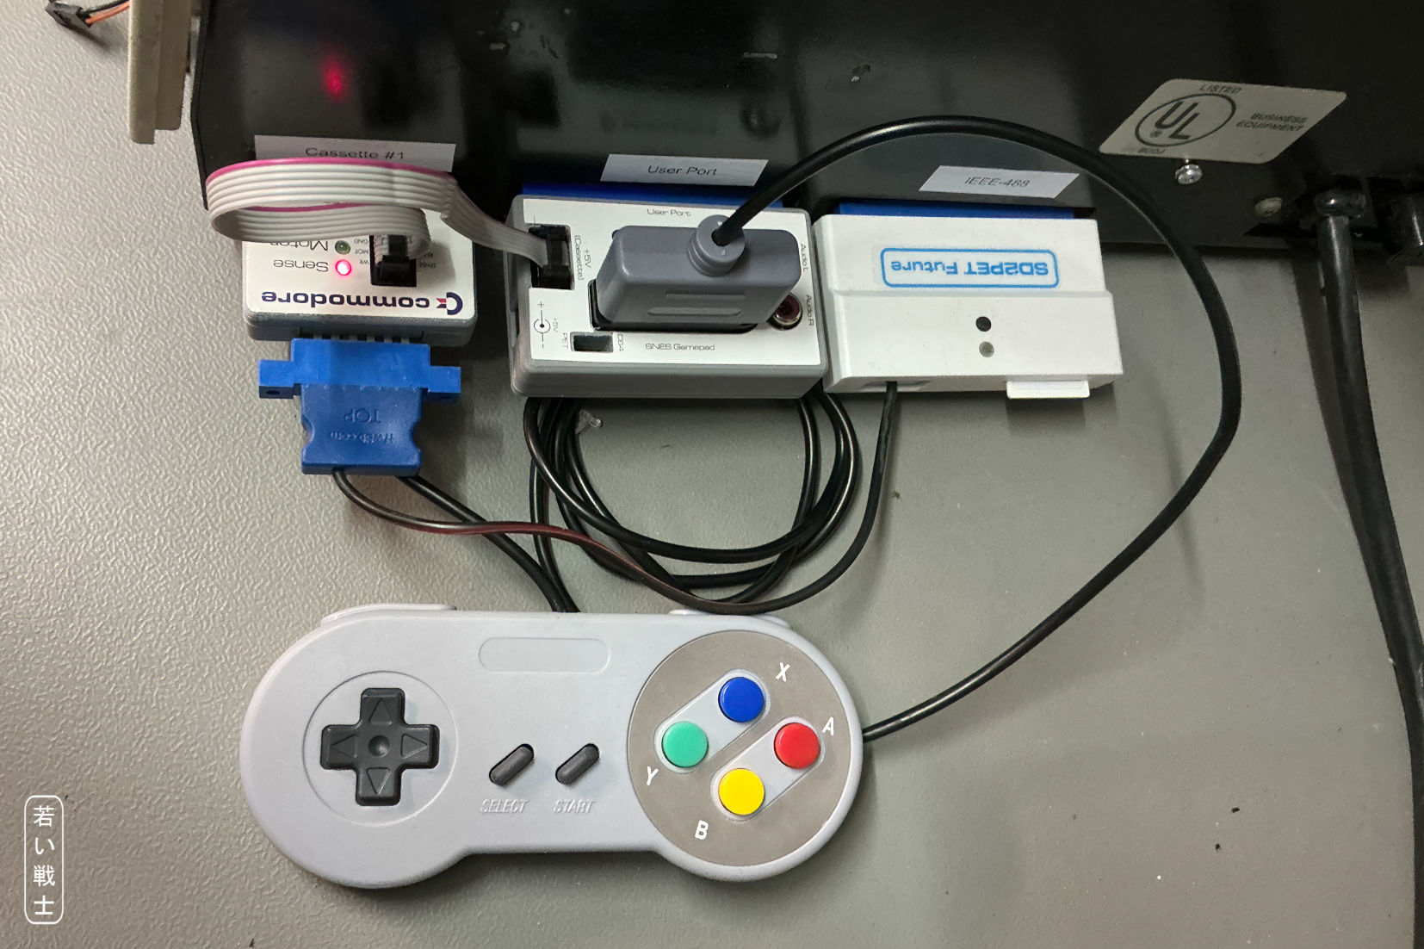
Figure 2: Backside of a CBM8032 - SNES Adapter with Cassette Port Dongle (and SD2PET Future)

Switch SW1
Since connecting the PET SNES Gamepad Adapter to a PET, while SW1 is set to “C64” can damage the PET, it should be considered well, if SW1 is installed.
SW1 is for using the +5V from the C64 User Port instead of the diagnostic cassette dongle or an external +5V power supply. If SW1 is not placed, the board works exactly like Rev. 0 (with the previously mentioned options for the supply voltage and a Rev. 0 case). It is recommended to install the switch only, in case the adapter is used only with a C64.

Pinouts

J1- User Port
2x12 Edge Connector, 3.96mm pitch
Pin | Signal | Gamepad
1, 12, A, N | GND | GND
3 | +5V | C64 only: +5V
F | PA3 | Clock
J | PA5 | Latch
K | PA6 | Data

2 – Power Supply Connector
5,5mm/2,5mm barrel connector (Cliff FCR681465P)
Pin | Signal
Center | +5VDC
Shaft | GND
This is an alternative power connector, which can be used with an external +5V power supply. It is not the preferred way of powering the module.

J3 - Power connector (from cassette port)
2x3 pin box connector
Signal | Pin | Pin | Signal
GND | 1 | 2 | +5V
- | 3 | 4 | -
- | 5 | 6 | -

Powering from cassette port is the preferred way, since it switches off together with the PET. This requires a Cassette Port Dongle (see C64 Diagnostic harness).

J4, J5 – Audio RCA jacks
2 vertical RCA jacks
Connector | Color | Center | Ring | Type
J4 | Red | Audio | GND | CUI Inc. RCJ-022
J5 | White | Audio | GND | CUI Inc. RCJ-023

Note: The CUI Inc connectors are pretty wide spread and available from Mouser and Digikey etc. There are acceptable and cheaper connectors from AliExpress, which perfectly fit into the footprint. Click URL
Both connectors are connected to the same source. The audio level is about 1.23V~ (+4dBu).

J6 – SNES Gamepad
SNES Gamepad Connector (vertical)
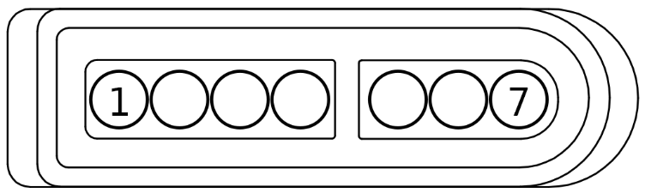
Figure 3: SNES Gamepad Connector
Pin | Signal
1 | +5V
2 | Clock
3 | Latch
4 | Data1
5 | Data2 (not connected)
6 | IOBIT (not connected)
7 | GND

Case
There is a 3D printed case and a case label for Rev. 1. In case SW1 is not placed, please use case and label for the PCB Rev. 0
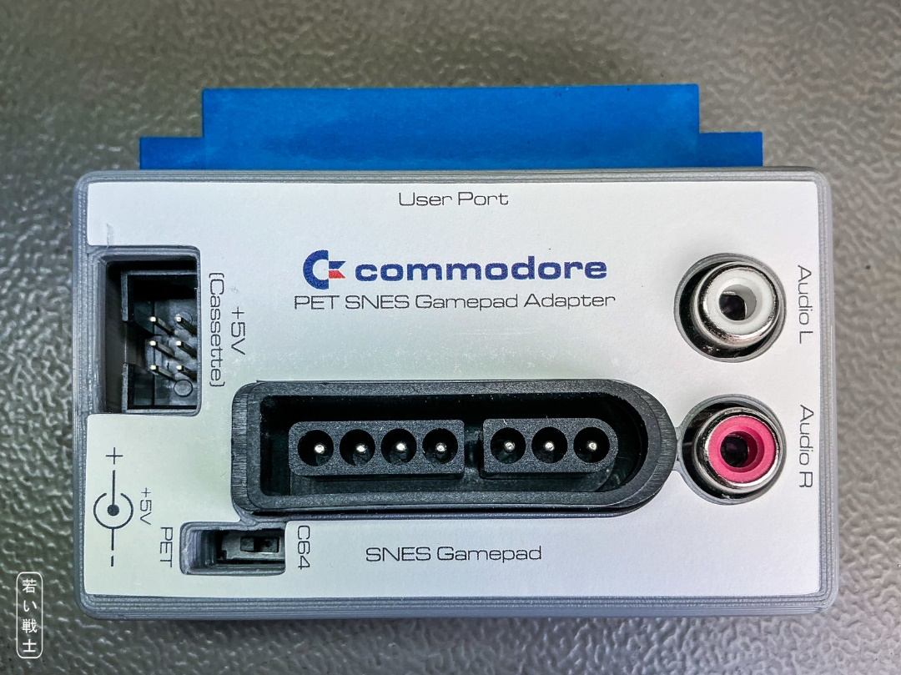
Figure 4: PET SNES Gamepad Adapter (in case)

Programming Hints
First, the data direction register of the user port needs to be set correctly. Clock (bit #3) and Latch (bit#5) are outputs of the user port, Data (bit#6) is an input:
POKE 59459,8+32
While scanning the gamepad, a (positive) latch pulse is required first:
POKE59457,32:POKE59457,0:REM LATCH PULSE
The gamepad outputs a 12 bit word, MSB first. After the latch pulse, the MSB is present at the data input (bit#6) of the user port.
GW=0:B=2048
FOR I=12 TO 1 STEP-1
IF PEEK(59457) AND 64 THEN GW=GW+B:REM IS BIT#6 SET?
B=B/2
POKE59457,8:POKE59457,0:REM PULSE CLOCK
NEXT I

An active data bit is LOW, this is, why it needs to be inverted
GW=4096 + NOT GW:REM INVERT GW
Now, the gamepad word can be decoded:
Bit | Bit Value | Gamepad
0 | 1 | Fire-R
1 | 2 | Fire-L
2 | 4 | X
3 | 8 | A
4 | 16 | Right
5 | 32 | Left
6 | 64 | Down
7 | 128 | Up
8 | 256 | Start
9 | 512 | Select
10 | 1024 | Y
11 | 2048 | B

The source is SNES TEST.BAS.PRG from the previously mentioned file snes_adapter.zip

Revision History

Rev. 0
Prototype, tested ok

Rev. 1
- SW1 for switching on the +5V from the C64 User Port.

